JAVASCRIPT LAB
PRACTICAL No. 10
Name:
PRN:
File Path:
Aim
To load and display JSON data using fetch() and jQuery $.getJSON(), and to render the results dynamically in a table.
Theory
JSON (JavaScript Object Notation) is a text format for sending data between a server and a webpage. A page asks for it with an asynchronous request, so the page keeps working while the data is on its way. Once the data arrives, JavaScript builds the table rows dynamically instead of writing them in HTML.
Feature | fetch() | $.getJSON()
Source | Built into the browser | jQuery library function
Returns | A Promise | A jqXHR (promise-like) object
JSON parsing | Manual: response.json() | Automatic
Error handling | .catch(); a 404 is not rejected, so check response.ok | .fail() runs on a 404 or network error

File | Purpose
index.html | Buttons, status line and the empty table
style.css | Green and copper colour scheme
script.js | Both loading methods and the dynamic table rendering
data.json | The data: an object with a "languages" array of 12 records
jquery.min.js | jQuery 3.7.1 stored locally (works without internet)
Procedure
- Create data.json holding an array of records (id, name, creator, year, paradigm, typing).
- Create index.html with two load buttons, a status line and a table with an empty <tbody>.
- Write loadWithFetch(): call fetch(), check response.ok, parse with res.json().
- Write loadWithJQuery(): call $.getJSON() and handle .done() and .fail().
- Write one render() function that loops over the records and appends a <tr> for each.
- Run the page with Live Server (fetch cannot read local files opened by double-click).
Key Code
// 1. fetch()
fetch("data.json")
.then(res => { if (!res.ok) throw new Error(res.status); return res.json(); })
.then(data => render(data.languages))
.catch(err => showError(err));

// 2. jQuery
$.getJSON("data.json")
.done(data => render(data.languages))
.fail((xhr, status, err) => showError(err));

Output
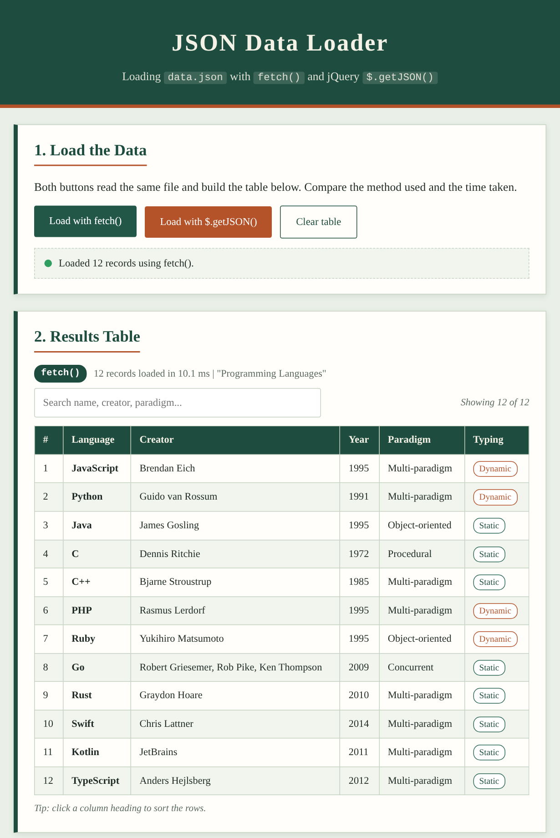  Fig. 1: Table built after clicking Load with fetch() | 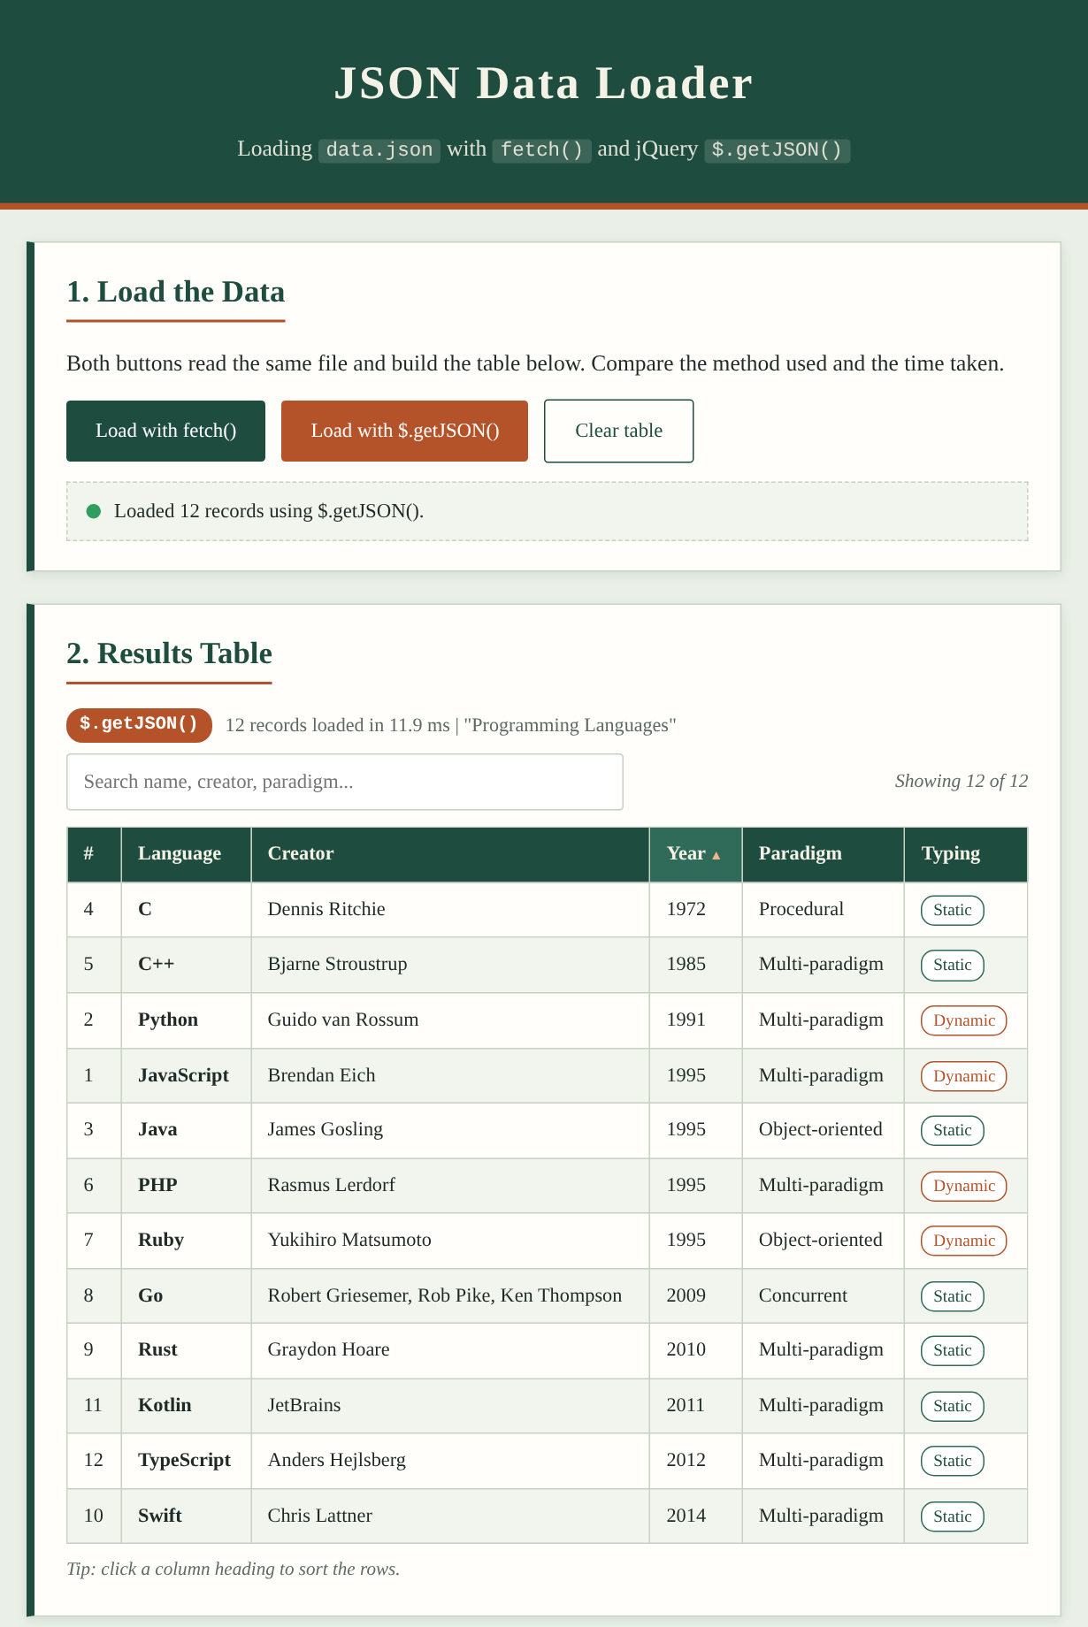  Fig. 2: Table built with $.getJSON(), sorted by Year

Method used | Result shown in the status line
fetch() | Loaded 12 records using fetch().
$.getJSON() | Loaded 12 records using $.getJSON().
Error test (404) | fetch: "Failed: HTTP 404" | $.getJSON: "Failed: Not Found"
Conclusion
Both fetch() and $.getJSON() loaded the same data.json file and produced an identical table of 12 records, which was built dynamically with JavaScript. fetch() is part of the browser and needs no library, but the JSON must be parsed and HTTP errors checked by hand. $.getJSON() is shorter and parses the JSON automatically, but it needs the jQuery library. Sorting and searching were done on the loaded data without requesting the file again.

